Access Statement for Roeburnscar Holiday Cottage
Roeburndale East Road, Wray, Lancaster LA2 8QS
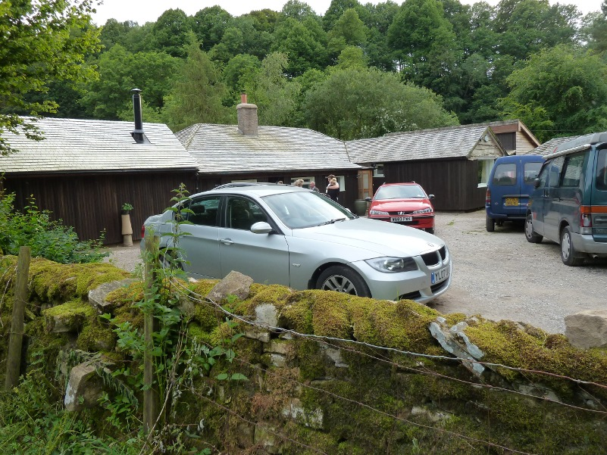
This access statement does not contain personal opinions as to our suitability for those with access needs, but aims to accurately describe the facilities and services that we offer all our guests/visitors.
Access Statement for Roeburnscar:

Introduction
Roeburnscar is a beautiful, eco-cottage set in 250 acres of wildlife paradise.
Suitable for groups of friends, family gatherings, walking and painting holidays.
It is peaceful retreat.
Location: In the countryside 0.5 Mile from Wray Village, 11 Mile Lancaster
Situated on a flat area with views over cliff to river
5 ground floor bedrooms
Bedrooms all have normal door size 740mm opening. 1 bathroom with low base shower and room for turning wheelchair
We look forward to welcoming you. If you have any queries or require any assistance please phone 015242 22214 or email roeburndalecampingbarn@phonecoop.coop

Pre-Arrival :
- See website www.roeburnscarholidaycottage.co.uk
- For Location and travel details see website
- Stations; Wennington 3 miles,Lancaster 11 miles
- No known accessible taxi. Local taxi's Bentham Taxis 015242 62511 County Cars of Hornby 015242 21604
- Bus services – accessibility, frequency every hour, distance of bus stop from property 15 minutes walk, route No 81 b, 81. From Lancaster or Kirkby Lonsdale , which stop to alight at Proctors Farm, Wray On Web site (bus Stop 0.5 Mile)Details on Web site.
- Special collection can be arranged. If you have difficulty in walking please ask us for assistance
- Tarmac road from Wray, Gravel drive 200 yards
- Local organic farm Growing with Grace can deliver full organic vegetables and other food. See website for contact

Key Collection, Welcome and Car Parking
- You will be welcomed on arrival and given keys and a tour around facilities.
- Parking next to door . Up to 6-8? cars Private parking gravel area
- Car park gravel leading onto concrete path. Slight slope down to house
- Automatic movement light from front door.
- Visitors can be dropped off by front door
- Help can be given with luggage on arrival

Entrance to Property
- Two main entrances
- Main entrance has a security movement light
- Kitchen entrance has 2 small steps 75mm. and 2 doors
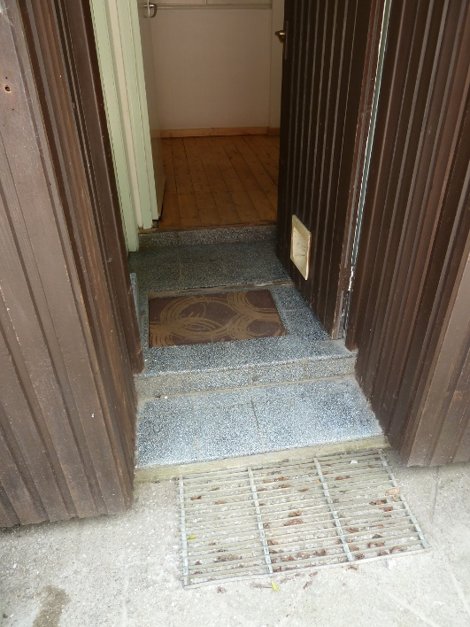
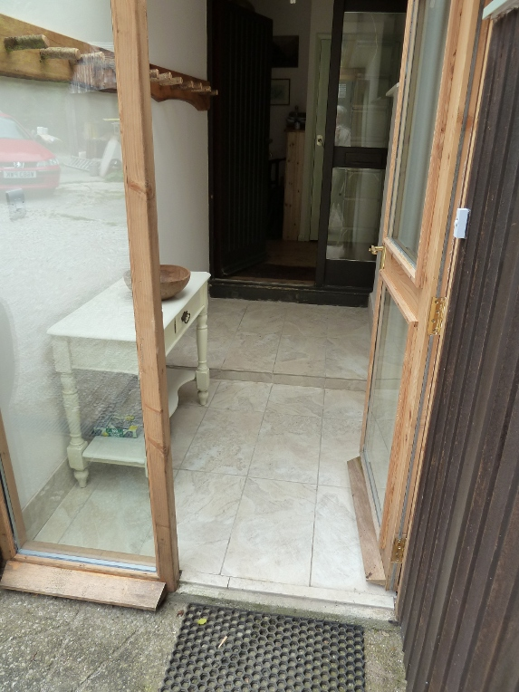
- Main entrance : outer door 730 mm inner door 800 mm wide includes 3 small steps (not together) 50-70mm high. stone tiles partly with slight slope
- Visitors normally shown around premises on arrival
- Flat can be accessed from main house on level floors or by its own entrance with double step up and no hand rail.

Halls, Stairs, Landings, Passageways
- Hall and passage ways all wooden floors
- No stairs
- Good ceiling lights

Sitting Room/Lounge
- Two Lounges
- Lounge faces south over looking river movable sofas and chairs central large carpet
- Door opening width: 740mm to hall. This is a tight entrance from hall to sitting room and to kitchen(see picture). Access to sitting room best from bedroom via verandah
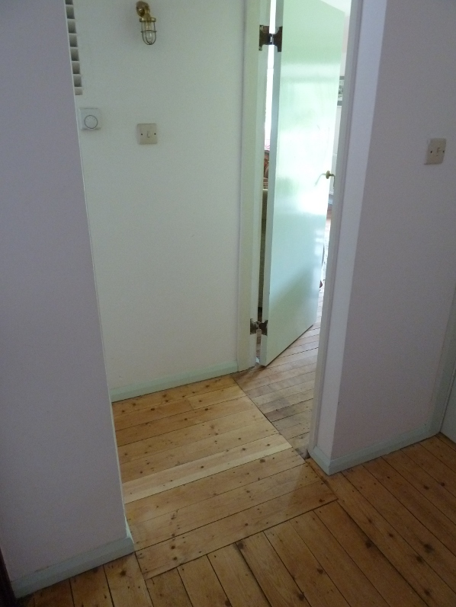
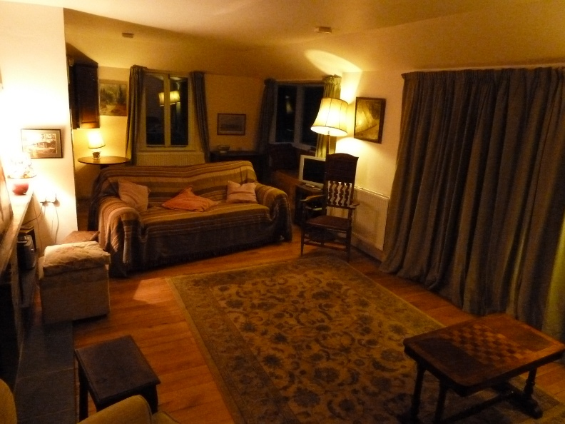
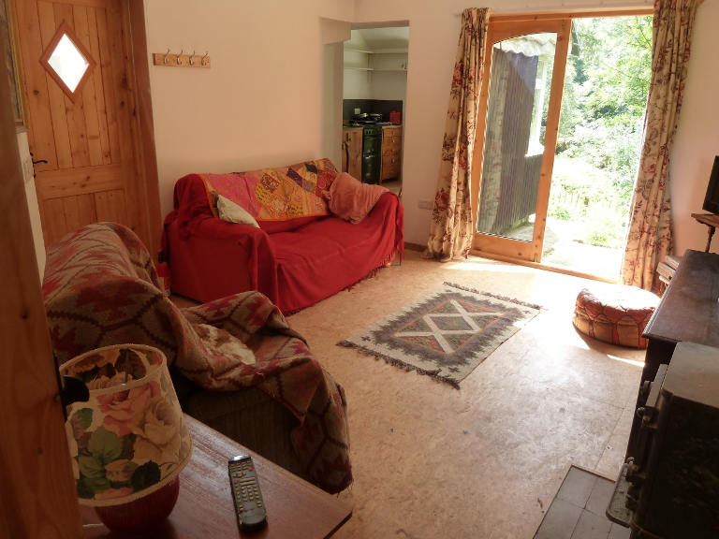
Large lounge all same level lots of space, 2 movable sofas, other chairs standard lamps. Big double doors open onto verandah and can access 2 bedrooms with a 10mm step down. This is most accessable route for wheelchair user .Wooden floor with large rug
- Flat lounge , smaller space with views to river and double doors to outside. Has sofa and electric recliner chair. Central light and table light
- the floor surface wood floor and small rug
- DVD player and cd/radio players in both lounges

Dining Room
- Dining Room
- Main house has large dining room level wooden floor
- Flat has small tight dining space in kitchen
- Large double doors to lounge sliding door to kitchen
- No large spaces to get around table but wheel chair could use lounge end of table
- Upright chairs one has arm

Kitchen
- Main large kitchen is on ground floor with wooden floor. Level access to dining room
- Entrance to kitchen from outside has 2 small 75mm steps
- Under counter cupboards and higher cupboards. Fridge freezer is in utility room (no wheel chair access)
- Standard under counter oven and dish washing machine
- Induction 4 ring plate . Unsuitable for use by people with pacemakers
- 3 basin sink
- Long kitchen counter
- Table and 4 basket work upright chairs

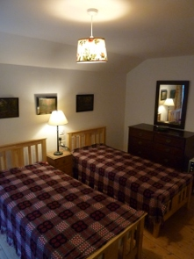
Bedrooms and Sleeping Areas
- 5 ground floor bedrooms
- 3 bedrooms also have door to verandah for outside access
- Door opening width 740mm
- Furniture can be moved around or removed on request
- Bed combinations: 2 twin,( 1 can be double/twin- zip-linked), 1 single, 1 double see website for room details and plan of building.
- Top of bed mattress 575mm
- Twin beds available in 3 rooms (maybe suitable for carer}
- What is the height of the bed(s) to the top of the mattress?
- Central ceiling light,and bedside lamp
- Walls white doorways green/grey. Floor natural wood
- Big twin bedroom has large built in wardrobe with shelves above.
- Floor Wood and rugs
- All cotton sheets washed in Ecover

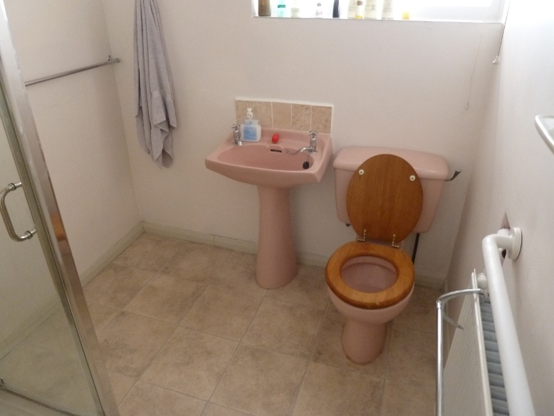
Bathrooms, Shower-rooms and Toilets
- Level access from the bedrooms to shared shower toilet and sink
- The shower has low lip tray. Good space outside for turning wheelchair
- What is the height of the WC from floor to seat?
- Wash basin has pedestal 750mm high
- Grab rail above radiator next to wc see above photo
- Normal twist tops Twist taps in shower.
- Bathrooms ceiling light and fluorescent tube shaving light
- The colour contrast white walls floor and wall tiles sandy pattern ,door green , floor surface non slip linoleum
- 2nd bathroom tight fitting wc, sink and bath
- Flat has small corner shower, sink and wc
Laundry/Utility Room
- Utility room adjacent to kitchen down small step. tight access. contains fridge freezer and sink with normal turn taps.
- Outside laundry room 70 m along concrete path. this contains washing machine, tumble drier, ironing board and sink with normal taps and small shop for organic food and farm produce

Garden
- Next to house small lawn adjacent to verandah., overlooking river with roses on fence.
- Basket work seating and wooden bench on verandah. Bird feeder can be seen from sitting room
- Outside flat 4 plastic chairs and table.on level concrete base. Area of lawn and herb spiral. (large steps down to outside flat and also from verandah to lawn.}
- Larger lawn down wide sloping grassed track also towards river.
- Steep paths lead into the woodland and along the river.

Additional Information
- Assistance dogs welcome
- Low-energy lighting is used
- Mobile reception very poor in house. only available outside about 10m from building-we have pay phone at house but emergency calls are free
- Nearest hospital for casualty Royal Infirmary Lancaster 12 miles 01524 65944
- Doctors 015242 71210 Kirkby Lonsdale and Hornby surgery or 015242 72510 Bentham and Ingleton
- Bridge End tea rooms 0.5 mile has disabled toilet and wifi

Contact Information
Address (Inc postcode): | Jane McArthur and Rod Everett roeburndalecampingbarn@phonecoop.coop Backsbottom Farm, Roeburndale West, Lancaster LA2 9LL
Telephone: | 015242 22214.
Email: | roeburndalecampingbarn@phonecoop.coop
Website: | www.roeburnscarholidaycottage.co.uk
Grid Reference: | SD60538 66837
Hours Of Operation: | normal lets Fri 5pm to Fri 10am
Local Equipment Hire: | Lancasterr Shopmobility runs on Wednesday and Friday, from 10am to 3.30pm.at The Cornerstone, Sulyard Street, LA1 1PX Shopmobility Kendal 01539740933, Forest of Bowland have Tramper vehicles for hire We have a mobility scooter that my mother used. Please let us know in advance if you need it for charging up battery
Local Accessible Taxi: | Red Bus available from Bentham with easy access .This can be arranged to pick up for shopping. Wheelchair taxi A to B Lancaster Taxi 015246000  More Local conventional taxis. Bentham Taxis 015242 62511 County Cars of Hornby 015242 21604
Local Public Transport: | accessibility, frequency every hour, distance of bus stop from property15 minutes walk, route No 81 b, 81. , which stop to alight at Proctors Farm Wray On Web site (bus Stop 0.5 Mile)Details on Web site. To get full details of local transport journey see travel line web site.

